Display Screen Equipment Risk Assessment Form

Please read the information below and complete all details fully.

If your assessment is a review and your workstation has NOT changed or altered since your last assessment please fill in your details in the bottom box only. For all NEW reviews or if your workstation has CHANGED please complete the top box and then the entire assessment.

User (Your Name):……………noble…………….…………………………………

Site:……………..………………………….Department:………………………………………..

Your Manager:………………… ……………………………………………………..

Checklist completed by:………………………………………………………………

Dated:…………………… ……………………………………………………………..

Any Further Action Required: YES/NO* Delete as appropriate

Assessment Checked By:……………………………………………………………

Display Screen Assessment Review ONLY

I confirm that my workstation has not changed or been altered in any way since my last Display Screen Assessment.

User (Your Name):……………………………………………………………………

Site:…………………………………….Department:………………………………..

Your Manager:………………………………………………………………………..

Checklist completed by:………………………………………………………………

Dated:…………………………………………………………………………………..

Assessment Checked By:……………………………………………………………

This checklist can be used as an aid to risk assessment and to help comply with the Schedule to the Health and Safety (Display Screen Equipment) Regulations.

Work through the checklist by ticking either the “Yes” or “No” column against each risk factor, if you tick “no” please give brief details in the “Your Comments ” box.

- “YES” answers require no further action.
- “NO” answers will require investigation by the Departmental Manager.

Remember the checklist only covers the workstation and work environment, you may also need to make sure the risks from other aspects of the work are avoided, for example by giving users health and safety training, and providing breaks and changes of activity.

Risk Factors |  |  | Things to consider | Your comments
Risk Factors | YES | NO | Things to consider | Your comments
- DISPLAY SCREENS

Are the characters clear and readable?  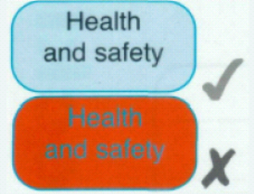 |  |  | Make sure the screen is clean and cleaning materials are made available. (Cleaning materials are purchased through your department)  Check that the text and background colours work well together.
Is the text size comfortable to read? |  |  | Software settings may need adjusting to change text size. (If you are unsure how to do this contact IT Helpdesk).
Is the image stable, i.e. free of flicker and jitter? |  |  | Try using different screen colours to reduce flicker, e.g. darker background and lighter test.  If problems still exist, get the set up checked. (Contact IT Helpdesk)
Is the screen’s specification suitable for its intended use? |  |  | For example intensive graphic work or work requiring fine attention to small detail may require large display screens.
Are the brightness and/or contrast adjustable? |  |  | Separate adjustment controls are not essential provided the user can read the screen easily at all times.
Does the screen swivel and tilt?  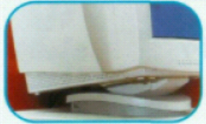 |  |  | Swivel and tilt need not be built in; you can add a swivel and tilt mechanism.  However, you may need to replace the screen if:  - Swivel/tilt is absent or unsatisfactory.  - Work is intensive and/or  - The user has problems getting the screen to a comfortable position.
Is the screen free from glare and reflections?  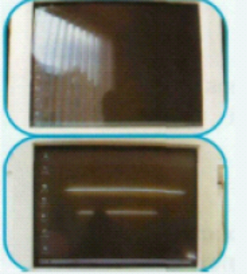  Are adjustable window covering provided and in adequate condition? |  |  | Use a mirror placed in front of the screen to check where reflections are coming from.  You might need to move the screen or even the desk and/or shield the screen from the source of reflections. (Ideally you should be sat sideways to the window).  Screens that use dark characters on a light background are less prone to glare and reflections.  Check that blinds work, blinds with vertical slats can be more suitable than horizontal ones.  If these measures do not work, consider anti-glare screen filters as a last resort.
- KEYBOARDS

Is the keyboard separate from the screen? |  |  | This is a requirement, unless the task makes it impracticable (e.g. where there is a need to use a portable).
Does the keyboard tilt? |  |  | Tilt need not be built in.
Is it possible to find a comfortable keying position?  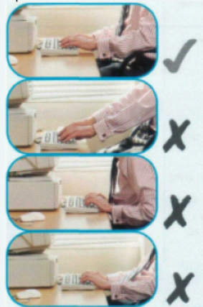 |  |  | Try pushing the display screen further back to create more room for the keyboard, hands and wrists.  Users of thick, raised keyboards may need a wrist rest.
Does the user have good keyboard technique? |  |  | Training can be used to prevent:  - Hands bent up at wrist.  - Hitting the keys too hard.  - Overstretching the fingers.
Are the characters on the keys easily readable? |  |  | Keyboards should be kept clean. If characters still can’t be read, the keyboard may need modifying or replacing, (Contact IT Helpdesk)  Use a keyboard with a matt finish to reduce glare and/or reflection.
- MOUSE, TRACKBALL ETC

Is the device suitable for the tasks it is used for? |  |  | If the user is having problems, try a different device. The mouse and trackball are general purpose devices suitable for many tasks, and available in a variety of shapes and sizes. Alternative devices such as touch screens may be better for some tasks (but can be worse for others).
Is the device positioned close to the user?  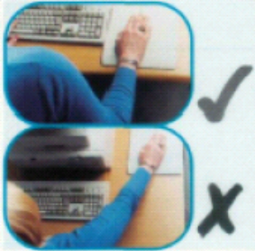 |  |  | Most devices are best placed as close as possible e.g. right beside they keyboard.  Training may be needed to:  - Prevent arm over reaching.  - Tell users not to leave their hand on the device when it is not being used.  - Encourage a relaxed arm and straight wrist.
Is there support for the device user’s wrist and forearm? |  |  | Support can be gained from, for example, the desk surface or arm of a chair. If not, a separate supporting device may help.  The user should be able to find a comfortable working position with the device.
Does the device work smoothly at a speed that suits the user? |  |  | See if cleaning is required (e.g. of mouse ball and rollers).  Check the work surface is suitable. A mouse mat may be needed.
Can the user easily adjust software settings for speed and accuracy of pointer? |  |  | Users may need training in how to adjust the device settings.
4. SOFTWARE

Is the software suitable for the task? |  |  | Software should help the user carry out the task, minimise stress and be user friendly.  Check users have had appropriate training in using the software, if not contact IT Support.  Software should respond quickly and clearly to user input, with adequate feedback, such as clear help messages.
5. FURNITURE

Is the work surface large enough for all the necessary equipment, papers etc?  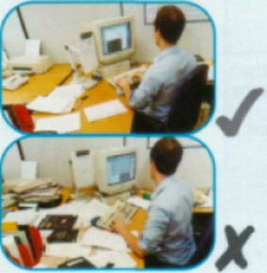 |  |  | Create more room by moving printers, reference material etc elsewhere.  If necessary, consider providing new power and telecom sockets so equipment can be moved.  There should be some scope for flexible rearrangement.
Can the user comfortably reach all the equipment and papers they need to use? |  |  | Rearrange equipment, papers etc to bring frequently used things within easy reach.  A document holder may be needed, positioned to minimise uncomfortable head and eye movements.
Are surfaces free from glare and reflection? |  |  | Consider mats or blotters to reduce reflections and glare.
Is the chair suitable?  Is the chair stable?  Does the chair have a working:  - Seat back height and tilt adjustment.  - Seat height adjustment?  - Swivel mechanism?  - Castors or glides? |  |  | The chair may need repairing or replacing if the user is uncomfortable, or cannot use the adjustment mechanism.
Is the chair adjusted correctly?  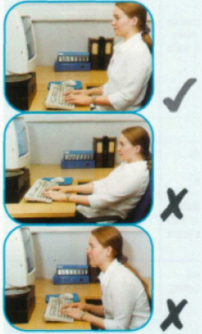 |  |  | The user should be able to carry out their work sitting comfortably.  Consider training the user in how to adopt suitable postures while working.  The arms of chairs can stop the user getting close enough to use the equipment comfortably.  Move any obstructions from under the desk.
Is the small of the back supported by the chair’s backrest? |  |  | The user should have a straight back, supported by the chair, with relaxed shoulders.
Are forearms horizontal and eyes at roughly the same height as the top of the VDU? |  |  | Adjust the chair height to get the user’s arms in the right position, and then adjust the VDU height if necessary.
Are feet flat on the floor, without too much pressure from the seat on the backs of the legs? |  |  | If not, a foot rest may be needed.
6. ENVIRONMENT

Is there enough room to change position and vary movement? |  |  | Space is needed to move, stretch and fidget.  Consider reorganising the office layout and check for obstructions.  Cables should be tidy and not a trip or snag hazard.
Is the lighting suitable, e.g. not too bright or too dim to work comfortably? |  |  | Users should be able to control light levels, e.g. by adjusting window blinds or light switches.  Consider shading or repositioning light sources or providing local lighting, e.g. desk lamps (but make sure lights don’t cause glare by reflecting off walls or other surfaces).
Does the air feel comfortable? |  |  | VDU’s and other equipment may dry the air.  Circulate fresh air if possible. Plants may help.  Consider a humidifier if discomfort is severe.
Are levels of heat comfortable? |  |  | Can heating be better controlled? More ventilation or air-conditioning may be required if there is a lot of electronic equipment in the room. Or, can users be moved away from the heat source?
Are levels of noise comfortable? |  |  | Consider moving sources of noise, e.g. printers, away from the user. If not consider soundproofing.
7. FINAL QUESTIONS TO USERS

- Has the checklist covered all the problems you may have working with VDU.

- Have you experienced any discomfort or other symptoms whilst working with your VDU.

- Have you been advised of your entitlement to eye and eyesight testing?

- Do you take regular breaks working away from your VDU?

- Have you any other problems to report?

